# UNIVERSITY OF ENERGY AND NATURAL RESOURCES, SUNYANI.

**SCHOOL OF SCIENCE**

**DEPARTMENT OF INFORMATION TECHNOLOGY**

**AND DECISION SCIENCES**

# 

**DETAILED DESIGN AND IMPLEMENTATTION DOCUMENT**

NYARKO BENITTA UEB3268122

QUANSAH ESTHER UEB3269222

BOAKYE YEBOAH SAMUEL UEB3217720

BOATENG KOFI KIEL UEB3226222

ELIJAH ABAANE UEB3238022

NATHAN KWAO UEB3221222

EMMANUEL OHENE UEB3240222

OWUSU ISAAC UEB3269322

DERRICK DONKOR UEB3270122

# Introduction

This document presents a comprehensive account of an ERP system specifically designed for the operational needs of a manufacturing company. The system enhances productivity, integrates various departments, and supports scalability to facilitate growth, ensuring a streamlined workflow throughout the manufacturing process. It aims to transform traditional manufacturing operations into a highly responsive and integrated environment that accelerates production and enhances product quality.

# System Architecture

This ERP system integrates essential business processes within a manufacturing environment to enhance operational efficiency and support strategic decision making. Hosted on a cloud platform for scalability, it features a user-friendly interface accessible through web and mobile devices and is structured into a three-tier architecture:

1. Presentation Layer: Tailored to accommodate users of varying skill levels, ensuring ease of use across different platforms. This layer is crucial for user engagement and operational control.

2. Application Layer: Manages business logic, data processing, rule enforcement, and user interaction. It acts as the brain of the ERP system, processing all critical operations.

3. Data Layer: Maintains a secure, centralized database that collates data across all modules, ensuring consistency and Realtime access. It is fundamental for data integrity and retrieval.

# Detailed Modules and Functionalities

## Production Planning and Control

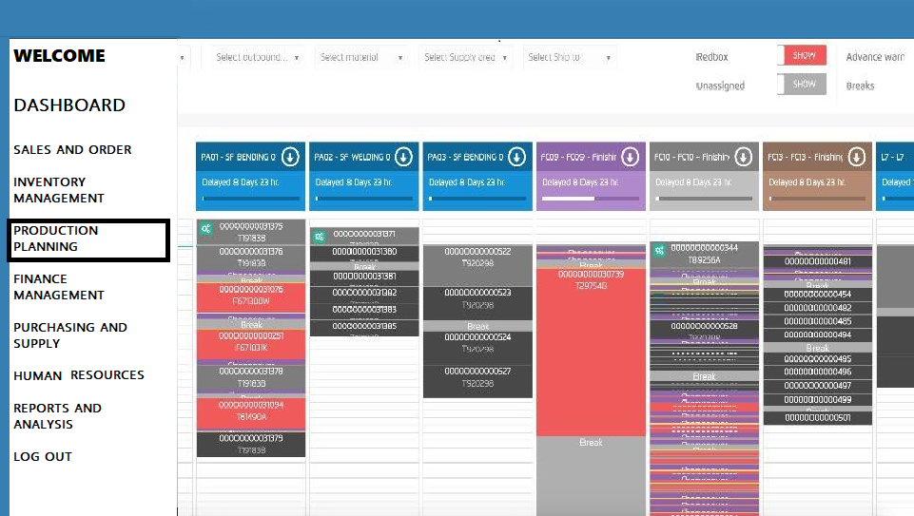

Tailored to the needs of manufacturing operations, it includes:

Master Production Schedule (MPS): Aligns manufacturing activities with demand forecasts and capacity constraints, dynamically adapting to changes. This schedule is crucial for maintaining production efficiency.

Work Order Management: Tracks production orders from start to finish, ensuring on time delivery and adherence to quality standards. It provides a clear view of production timelines and resource allocation.

Quality Control: Embeds quality checks throughout the manufacturing process to uphold product standards. It significantly reduces the risk of product defects and ensures compliance with industry standards.

Resource Allocation: Efficiently allocates human and machine resources to meet production demands, optimizing usage and reducing costs. This feature helps in maximizing productivity and minimizing waste.

## Sales and Order Processing

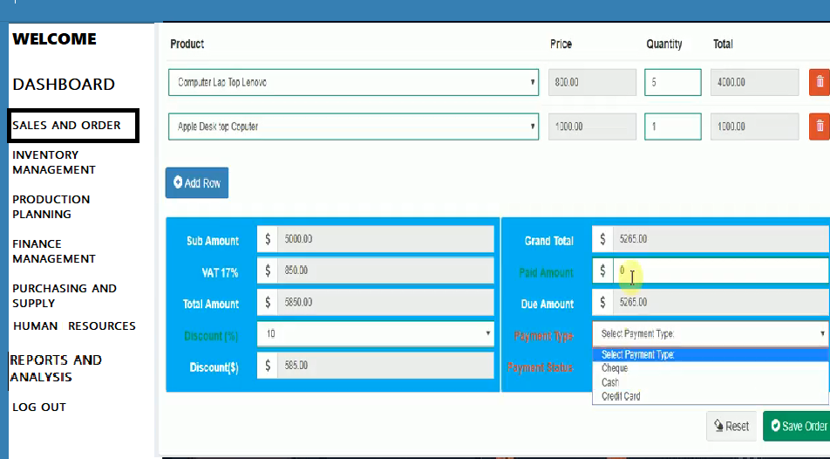

Enhances the sales interface with Realtime tracking, automated confirmations, and logistics integration. The CRM component manages extensive customer data, enhances interaction tracking, and supports targeted marketing strategies. It ensures a smooth order process from placement to delivery, enhancing customer satisfaction and streamlining sales operations.

## Purchasing and Supplier Management

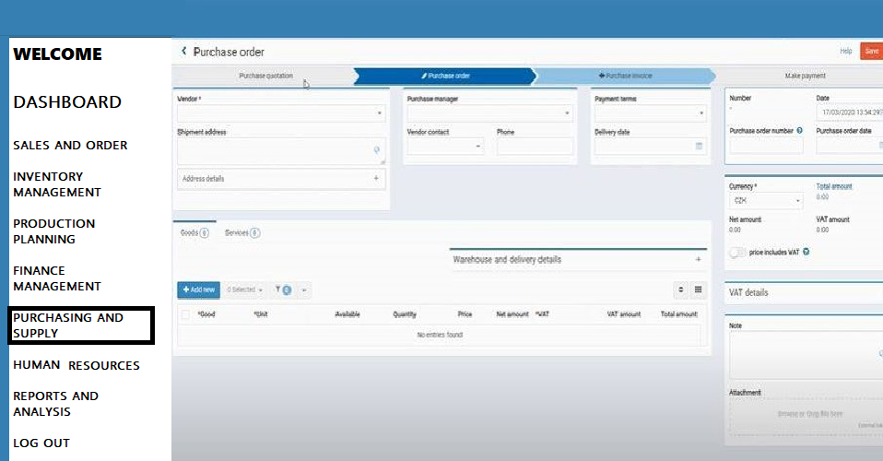

Facilitates effective supplier relationship management, contract management, and purchase order processing, complemented by detailed spend analysis for cost optimization. This module is critical for maintaining strong supplier relationships and achieving cost efficiency in purchasing operations.

## Finance and Accounting

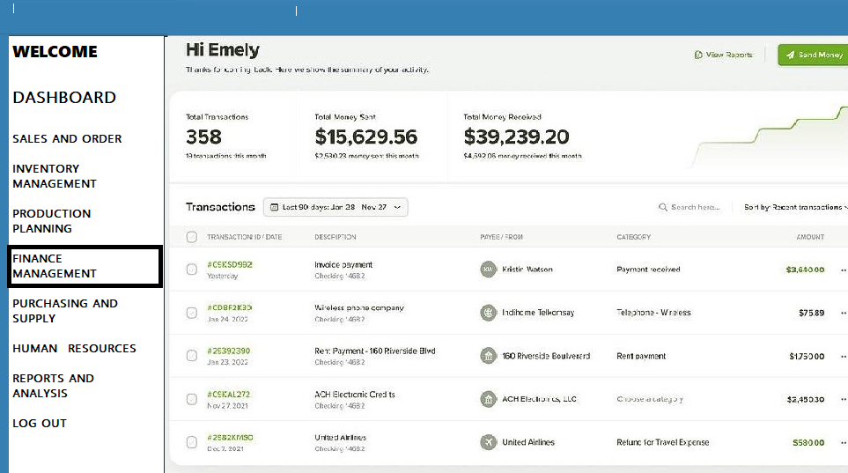

Centralizes financial transactions in a comprehensive General Ledger, supports asset management through its lifecycle, and provides detailed financial planning and regulatory compliance tools. This module ensures financial stability and strategic financial management, crucial for long-term business sustainability.

## Inventory Management

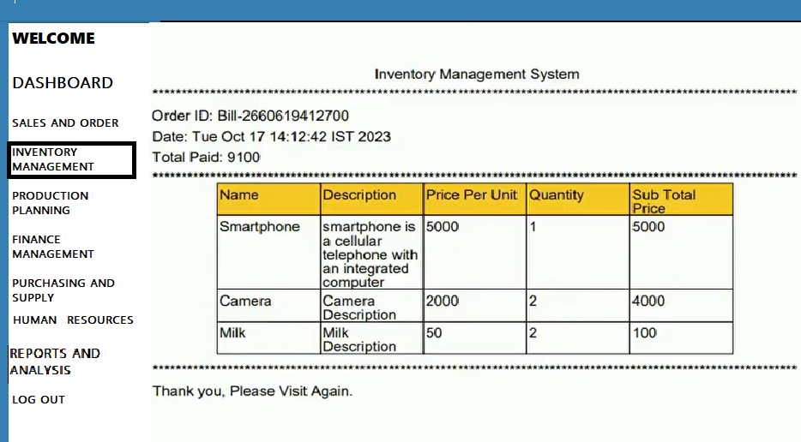

Optimizes stock levels through automated purchase orders based on predefined thresholds and enhances stock management efficiency with features such as dynamic threshold adjustments and supplier integration. Includes advanced inventory forecasting techniques to support effective demand planning. The system also provides detailed reports on inventory status, helping managers make informed decisions to optimize inventory levels and reduce costs.

## Human Resources Management

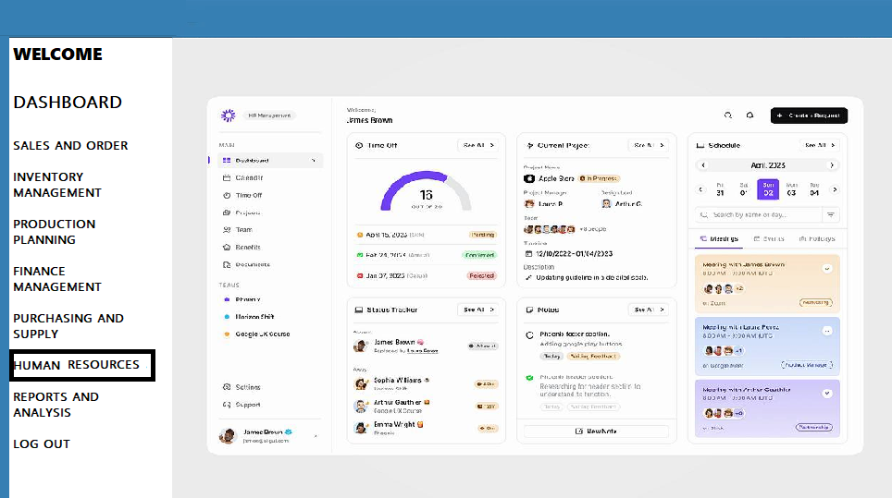

Manages comprehensive employee data, automates payroll, and supports talent management and benefits administration, ensuring efficient human resource operations. It enhances employee satisfaction and productivity through effective HR management practices.

## Reporting and Analytics

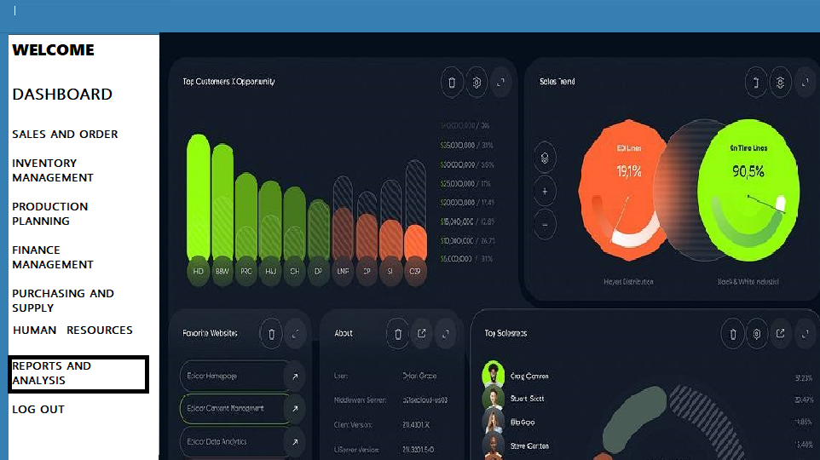

Provides advanced reporting tools, including customizable dashboards, Realtime data access, detailed data visualization, and analytical insights to inform strategic decision making. This module transforms data into actionable insights, driving business growth and operational efficiency.

# Implementation and Deployment Plan

## Redeployment

Focuses on training and system testing specific to manufacturing requirements. This phase is critical for ensuring that all system functionalities align with specific business processes.

## Deployment

Includes system setup, integration with existing manufacturing systems, and strategic data migration. This stage is crucial for ensuring a smooth transition to the new system without disrupting ongoing operations.

## Post deployment

Emphasizes continuous support and feedback integration to enhance system performance. This phase helps in adjusting the system based on real-world use and feedback.

Continuous Improvement: Ensures the system evolves with technological advances and operational demands through regular updates and training. It is key to maintaining system relevance and performance.

# Security Features

Employs robust security measures tailored to protect sensitive manufacturing data, including encryption, multifactor authentication, regular security audits, and comprehensive network security protocols. Ensures data integrity through regular backups and compliance management. These features safeguard against both internal and external threats, ensuring a secure and reliable environment for business operations.

# Conclusion

This ERP system is an essential tool for enhancing the efficiency and scalability of manufacturing operations. With its comprehensive design and focus on integration, it supports a seamless workflow, improves decision making, and prepares the company for future growth and challenges in the manufacturing sector. The implementation of this ERP system represents a significant investment in technology that will yield improvements in efficiency, quality, and customer satisfaction.